**I would really be grateful if you start to build the Lightning Capture Device, that you go to the Photrio thread and say hi. Also please post photos of your completed project.**Please refer to the Photrio thread for further build help  
[Lightning Capture Device - Cheap - Simple & it works (photrio.com)](https://www.photrio.com/forum/threads/capture-lightning-device-cheap-simple-it-works.207958/)

GitHub repository where all documentation & code can be found. [billbill100 (github.com)](https://github.com/billbill100)

V1.1 30/07/2024

**Lightning Capture Operating Instructions**

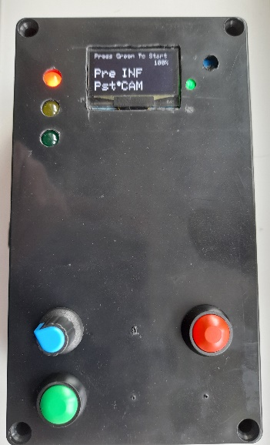

**Buttons**

Blue button. Each time this button is pressed, the red marker will move to the next parameter.

Blue knob. Turning the knob will change the parameter.

Green. Starts the Lightning Capture.

Blue button. Ends Lightning Capture & returns to parameter screen.

**LEDs**

Red LED. Power.

Yellow LED. Half Press Shutter – watching for Lightning.

Green LED. Full Press Shutter – taking a photo.

**Light Sensor**

Blue/White screw. Adjusts sensitivity of Light Sensor.

Green LED. Light Seen

**On-Screen Parameters**

**Pre.**   
Sets how long the camera will wait with shutter ‘half-press’ watching for lightning.

**Pst** (post)  
How long the shutter will stay open for, when triggered by lightning.

**Battery**  
Alternates between voltage and percentage. Only show whilst in parameter menu

**Note:-**   
The two parameters above are normally set to INF (infinite) and Cam (camera settings). However, they can be changed from 1/1000s to 480 seconds. See ‘Fun & Games’ below.

**Basic operation – Full version**The Light Sensor must be adjusted using a small screwdriver, so that in ambient light, the green led on the board just turns off. Note, there is a secondary green power light on the board, which is always on.  
  
The Lightning Capture is connected to the camera using a suitable shutter release cable.  
  
The camera must be in manual mode, including focus & iso.  
Focus the camera either at infinity or at a suitable distance, if including foreground. Then ensure auto-focus is turned off.  
  
Set the camera iso, shutter speed and aperture as appropriate. This will involve a little trial and error and setting will depend on ambient light and if you are being creative with light-painting or fill flash for the foreground.  
  
Press the Green start button & the camera will act the same way as half-pressing the shutter button and the Yellow LED will illuminate (ensure LEDs will not fog the photo)  
  
When lightning is seen, the shutter will be fully pressed and the Green LED illuminate.   
  
The camera will now take a photo, for the duration the camera shutter speed has been set to.   
  
Note:- The Lightning Capture box has no idea of the camera settings, so after seeing lightning, it will immediately release the shutter and half-press again, watching for the next lightning strike, but the camera settings take priority.  
  
To stop lightning-capture, press the blue knob. The unit will close the shutter and return to the initial menu screen.

**Basic operation – Minimal version**  
The Light Sensor must be adjusted using a small screwdriver, so that in ambient light, the green led on the board just turns off. Note, there is a secondary green power light on the board, which is always on.  
  
The Lightning Capture is connected to the camera using a suitable shutter release cable.  
  
The camera must be in manual mode, including focus & iso.  
Focus the camera either at infinity or at a suitable distance, if including foreground. Then ensure auto-focus is turned off.  
  
Set the camera iso, shutter speed and aperture as appropriate. This will involve a little trial and error and setting will depend on ambient light and if you are being creative with light-painting or fill flash for the foreground.  
  
When powering on, the unit goes straight into Lightning-capture mode and the Yellow LED will illuminate (ensure LEDs will not fog the photo) (There is no Green button to start)  
  
When lightning is seen, the shutter will be fully pressed and the Green LED illuminate.   
  
The camera will now take a photo, for the duration the camera shutter speed has been set to.   
  
Note:- The Lightning Capture box has no idea of the camera settings, so after seeing lightning, it will immediately release the shutter and half-press again, watching for the next lightning strike, but the camera settings take priority.  
  
To stop lightning-capture, turn the unit off.

**Fun & Games with the Full version.**The ‘pre’ parameter specifies how long the Lightning Capture will wait for lightning. The default is infinity, however this can be set between infinity, 480 seconds to 1/1000s. At the end of this time, a photo will be taken, even if lightning is not seen. This can be used as an intervalometer, or if the camera has pre-capture & is set to do so, one can save the pre-capture photographs.  
  
The ’Pst’ or Post parameter sets how long the shutter stays open for. Normally this is set on the camera, however if the camera is set to Bulb mode, then the Lightning Capture can control the exposure time.   
  
The camera of course, need not be set to Manual or Bulb mode. For example, it could be set to continuous shooting at 1/60s. By setting the Pst to 5s, one would get a burst of 1/60s stills for 5 seconds.  
  
This could be used to take a series of shorter photographs once lightning is seen, for manual blending & editing.  
  
For cameras with pre-capture, this can be used to capture the pre and post lightning (removing latency issue) by setting the camera up for pre-capture. When lightning is seen, the pre-captured images will be saved and a series of post-images will be taken depending on the ‘Pst’ setting.  
  
**Note:-** The Lightning Capture has a minimum shutter press length of 1/1000s. It is unlikely a faster shutter speed would be required, however if the camera is set to something like 1/8000s, there may be multiple 1/8000s images taken, as the camera will ‘see’ the shutter is pressed for 1/1000s.

**General Notes**  
Shutter latency is the time from when the shutter is pressed to the time the camera has lifted the mirror & opened the shutter. This can be many milliseconds. The Lightning capture also has latency between lightning being seen and it operating the camera. This cannot be helped. All electronics will have some latency.

For this reason, the Lightning Capture has been coded to minimise latency, with priority given to looking for lightning and operating the shutter, before updating the display. This is also why the camera sits in ‘half-press’ mode waiting for lightning.  
  
**Caveat.**  
The Lightning Capture has been built & tested and all works well. The one thing that has not been tested is photographing actual lightning! It is just a waiting game until a suitable storm comes along.